|  |
| --- |
| C:\Users\watanabe\AppData\Local\Microsoft\Windows\INetCacheContent.Word\keio_emblem.png  **庆应义塾大学创业者育成项目**  **Keio Entrepreneurship Program** |
| 2018 年 2 月 4 日（周日）- 2 月 14 日（周三）  Feb.4 2018 (Sunday) - Feb.14 2018 (Wednesday)  C:\Users\watanabe\AppData\Local\Microsoft\Windows\INetCacheContent.Word\keio07.jpg |

**庆应义塾大学创业者育成项目**

**Keio Entrepreneurship Program**

**项目概况**

The Keio Entrepreneurship Program offers lectures with actual business examples and a company visit for participants to learn about the basic knowledge and ideas required to start a business, how to create customer value, and how to get a competitive advantage, among others. Professionals who support companies’ business management, entrepreneurs who have started their own start-up companies, and an investor who works for a venture capital firm are scheduled to be invited as the lecturers. A Business Idea Competition will be held on the final day. Another investor will give feedback for a business idea to be presented by each group to wrap up the Program. This is an intensive, practical short-term program that also provides a great opportunity for participants, including Keio students, to interact and deepen their understanding of different cultures.

庆应义塾大学创业者育成项目提供以真实企业案例为蓝本的课程以及一次企业见习的机会，让参与者们学习创业、创造顾客价值、如何得到竞争优势等等的基本知识。被邀的授课者有帮助企业进行商务管理的教授、自主创业的企业家、风险投资家等。项目最后一天将会举行商业理念比赛。投资家将对每个小组的商业理念进行反馈，以此使项目完美落幕。这是一个高强度且实用的短期项目，为参加者（包括庆应的学生）提供绝佳的机会来探讨并加深对不同文化的理解。

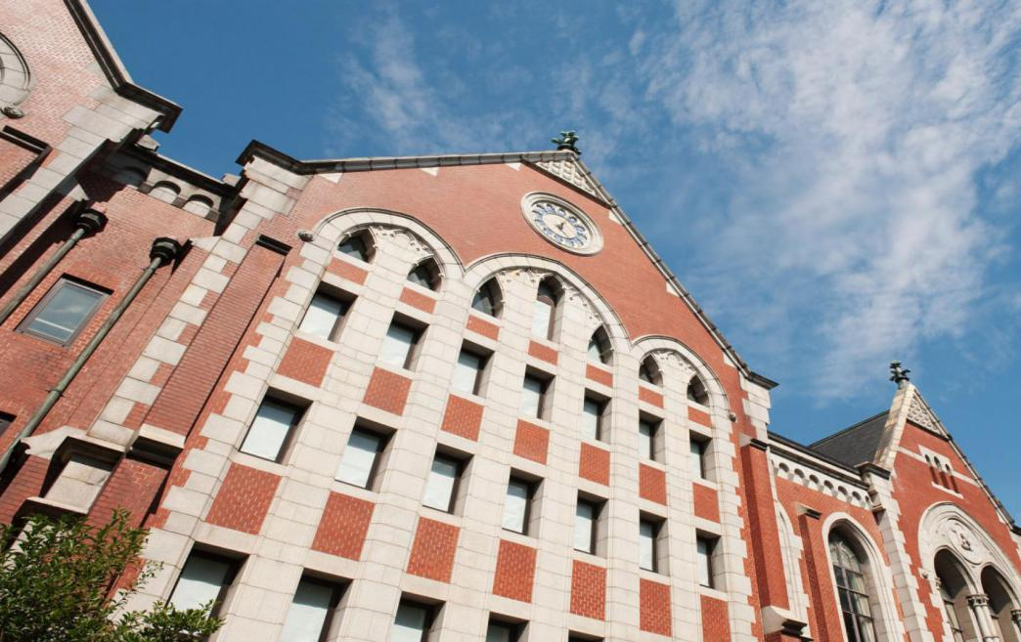

**大学介绍**

**Keio University**

Established in 1858 by Yukichi Fukuzawa as a small school of Western learning, Keio has a history as Japan’s very first private institution of higher learning. Over 150 years since its founding, Keio has thrived under its founder’s motto of *jitsugaku*, or empirical science, as it continues to transform Japan as a modern nation through contributions to education, research, and medicine. Today, Keio University is playing a leading role in the academic world, attracting highly talented students and researchers from home and abroad. Looking ahead, it endeavors to make further contributions to society, strengthen its international reputation, and solidify its position as a world-leading research university. With world-class research facilities and wide-ranging academic programs in Tokyo, the world’s biggest metropolis, Keio is an exciting place to learn, grow, and connect with people from around the world.

庆应作为福泽谕吉在1858年创立的小规模西式学校，是日本历史上的第一所私立高等教育学府。自成立的150多年来，庆应秉承了创始人福泽的座右铭“实学”（即比起理论更注重实用性的学问），通过其对教育、科研和医学的贡献，帮助日本转型为现代化国家。如今的应庆义塾大学在学术界处领导地位，吸引了众多极具天赋的海内外学生和研究人员。展望未来，庆应努力为社会做出更多贡献，加强国际声誉，巩固其世界领先的学术大学地位。拥有世界级的研究设施和广泛的学术项目，位于国际大都市东京的庆应是一个学习、成长、与来自世界各地的人们交流的极佳平台。

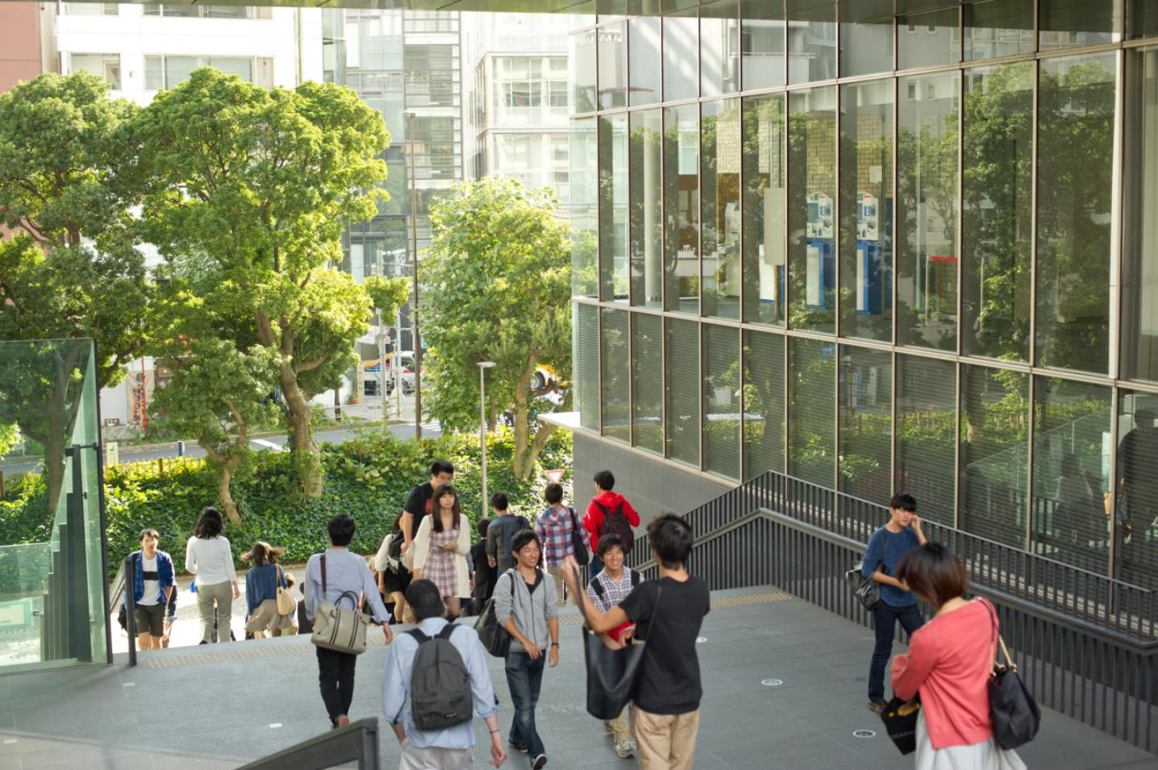

* **行程时间：**2018年2月4日－2018年2月14日（11天）

Schedule: Feb.4 2018-Feb.14 2018(11 days)

* **课程语言：**英语

Language: English

* **上课地点：**庆应义塾大学三田校区

Location: Mita Campus, Keio University

* **项目认定：**参加该项目学生可获庆应义塾大学项目结业证书

\*Each participant will be issued a Certificate of Completion.

* **申请截止：**2017年12月1日（定员25～30名）

Application deadline: Nov.3 2017 (Participant capacity: 25-30)

* **申请对象：**在读本科・研究生，具备较强的英文沟通交流能力。

※ 英语要求CET 6级，并提交大学在校期间的成绩证明书。

成绩证明为参考是否能够参加本项目的重要评价标准。

**Eligibility:**

* Applicants must be enrolled as full-time students in an undergraduate (bachelor's level) or graduate (master's level) program at a Chinese university at the time of application and during the program being held.
* Applicants must be fluent in English.(CET-6 or above)
* \*This program is taught entirely in English.

申请条件：

- 申请者必须为全日制大学在读本科生或研究生。

- 申请者必须有流利的英语水平（大学六级或以上）。

- \*本项目为全英语授课。

**Application Documents:**

* Application form
* Statement of purpose (less than 250 words, typed or written clearly in English)
* A copy of grade report or transcript that includes all the coursework and grades

(\*If issued in a language other than English, please attach an English translation.)

* An extra set of copies of all the documents above

申请材料

- 申请表

- 申请文书

- 包含所有课程分数的成绩单（原件及英文版）

- 另准备一份上述所有材料

**選考結果発表**：

Screening results will be announced by around December 8.

录取结果将由12月8日宣布。

**讲师介绍 (\*2017参考）**

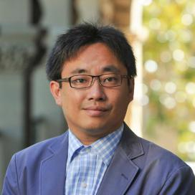

**Kanetaka MAKI**

**(Assistant Professor, National Graduate Institute for Policy Studies)**

●Professional Career

Kanetaka Maki holds a Ph.D. in Management from the University of California, San Diego.

He also serves as Visiting Assistant Professor of University of California, San Diego and Affiliated Fellow at National Institute of Science and Technology Policy.

Prior to joining GRIPS, Maki has worked at Stanford University and Keio University.

His specialties are Science Policy and Entrepreneurship. His current research interests are "The success factor of university-based startups" and "Comparison study of innovation system between the US and Japan."

説明: bb29a1ea15ce36d3e80963fd3af33a87e850b10f.png

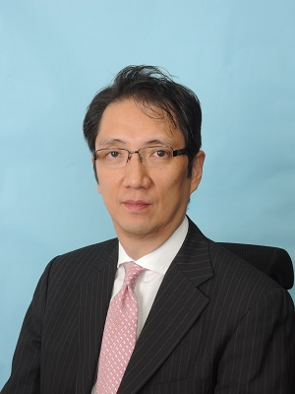

**Naonori KIMURA**

**(Partner, Managing Director, Industrial Growth Platform, Inc.)**

●Professional Career

Naonori Kimura’s activities include numerous advisory services such as corporate strategies including breakthroughs, strategy shifts and re-growth initiatives. He has advised clients on business management streamlining, structural reforms, financial strategy, new business development, M&A strategies, and cost competitiveness. Prior to IGPI, he launched a venture business, worked with NCR Japan and later at Towers Perrin and Arthur D. Little Japan.

He graduated from Keio University, School of Economics, and holds an MBA from the University of Leicester and an MS in Finance from the Lancaster University. He also completed AMP in Harvard Business School.説明: bb29a1ea15ce36d3e80963fd3af33a87e850b10f.png

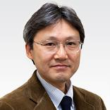**Masahiro OKADA**

**(Professor, Keio Business School)**

●Professional Career

Masahiro Okada serves as Professor of Keio Business School. Earlier in his career, he worked for Honda Motor Co., Ltd. and Arthur D. Little Japan, Inc. He also worked as a fellow at MUSE Associates, Inc., Palo Alto, CA.

Okada graduated from Waseda University, School of Political Science and Economics, and holds an MBA from the Graduate School of Business Administration, Keio University and a Ph.D. in business administration from Fisher College of Business, the Ohio State University.

説明: bb29a1ea15ce36d3e80963fd3af33a87e850b10f.png

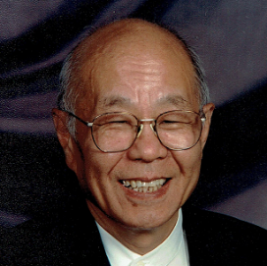**Toshikata AMINO**

**(Executive Vice President (Retired), Honda of America　Mfg., Inc.)**

●Professional Career

Toshikata Amino serves as a fellow of Ohio State University.

He served as Executive Vice President of Honda of America Mfg., Inc.

Former Adjunct Professor, Keio Business School

Director, Cross Cultural Management Institute

説明: bb29a1ea15ce36d3e80963fd3af33a87e850b10f.png

**Hitoshi SUGA**

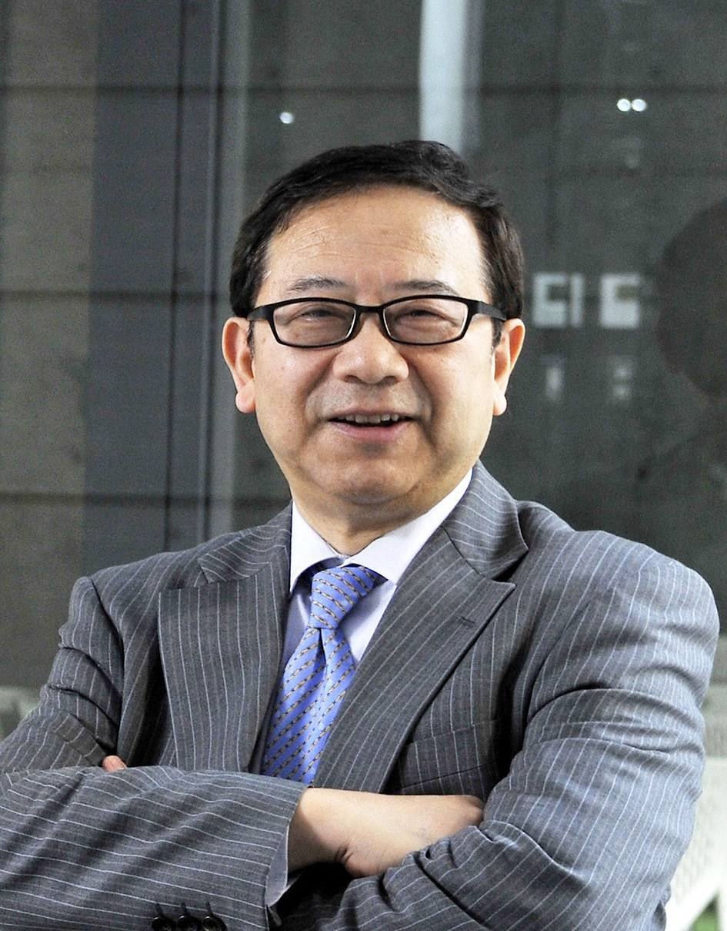

**(Special Advisor to President (ex-Vice Chairman),**

**Tully's Coffee Japan Co., Ltd.)**

●Professional Career

Mr. Suga is one of the most experienced and prominent Japanese venture capitalists and has substantial proven track record in Japan and the global venture investment, who presently serves as Professor and Associate Dean, Yamanashi Gakuin University, International College of Liberal Arts (iCLA) and a few other highly prestigious universities in Japan teaching entrepreneurship. He has spent total 24 years of his career at Mitsui & Co. (Mitsui Bussan). Since 1988 until 1996, he was responsible for planning and implementing various successful cross border and domestic M&A deals at Mitsui Bussan's Corporate Planning Div., and its clients totaling more than $900 Million. In 1996, he founded and became President and CEO of MVC Corporation (Presently Mitsui Global Investment), a global venture capital/PE arm of Mitsui. While at MVC Mr. Suga has identified and invested in various fast-growing start-up companies and served as board members of several of MVC’s portfolio companies, 5 of which have successfully gone public and 2 achieved successful trade-sales. One of the most successful investments he has made is Tully’s Coffee Japan (TCJ) for which Mr. Suga has acted as its angel investor through MVC, Vice Chairman and a board member, and mentor to its Founder/President, Mr.Kouta Matsuda, which went NASDAQ-J (now JASDAQ Market) in the shortest record of 2-1/2 years after the incorporation among all the public food companies in Japan. In November, 2006, as its Vice Chairman, he has played a major role to successfully sell the majority control of TCJ to ITO EN, LTD., a major TSEC-I listed green tea and other beverages company. He still serves as TCJ's Special Advisor to President while having various board memberships and advisory functions of emerging and high growth companies. In 2008, Mr.Suga received the Minister of Small Business Agency Award from METI(Ministry of Economy, Trade & Industry)-affiliated “Japan Venture Award 2008”(Nurturing Entrepreneurs Section)

Mr. Suga holds an MBA degree from Harvard Business School and BA degree from Waseda Univ. (School of Political Science and Economics).

説明: bb29a1ea15ce36d3e80963fd3af33a87e850b10f.png

**Nobuaki KITAGAWA**

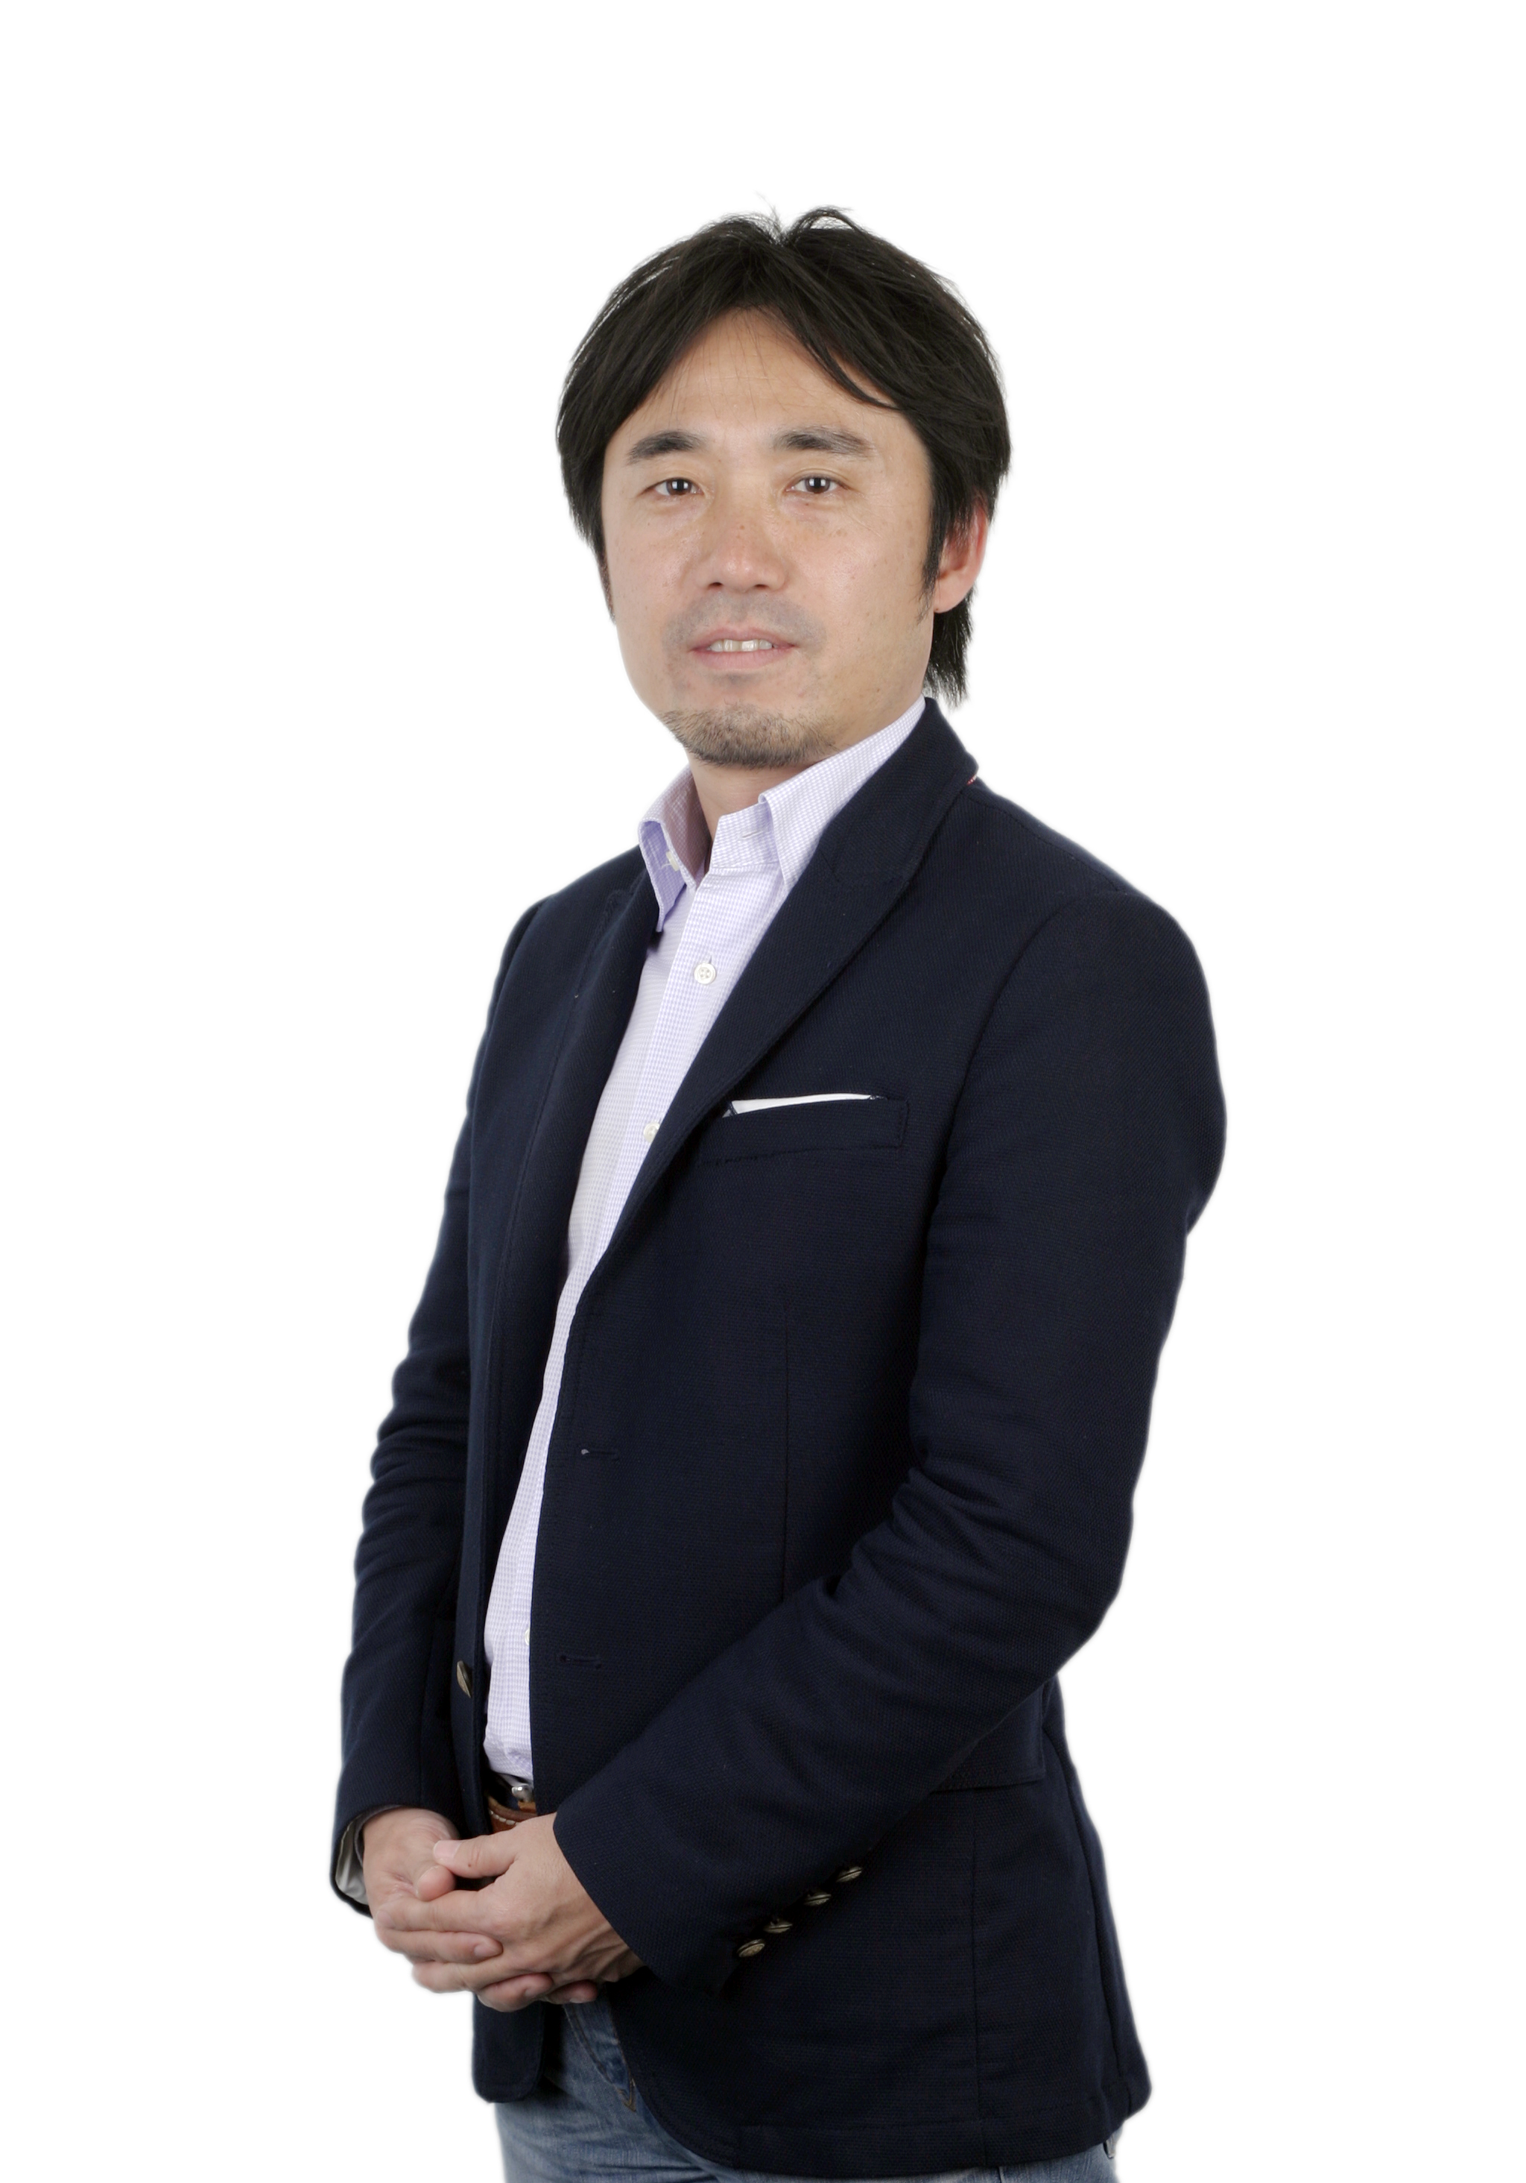

**(Managing Director, CEO of CyberAgent Ventures Beijing Co.,Ltd.)**

●Professional Career  
Nobuaki Kitagawa is responsible for all of the company's investments in China, Taiwan,

SEA and Korea. Since joining to CyberAgent Ventures（CAV) in 2006, Kitagawa has led international expansion from

no investment outside Japan then to more than 65 overseas investments including Youku-Tudou (China, NYSE: YOKU), Kakao Corp (Korea: 043720KQ), VIPABC (China), Tokopedia (Indonesia) and Vatgia,com (Vietnam). Under his leadership, CyberAgent Ventures has invested about US$65M into the region since 2006. He also has build his overseas investment team from zero in 2006 to 20 professionals located in the five countries at present.

Prior to CAV he had more than 10 years' experience in the telecom industry working for Japan's NTT DoCoMo.

He graduated from Hitotsubashi University, Economics, and holds an MBA from Georgetown University in the United States.

He has been living in China since 2008, currently based in Shanghai with his family.  
説明: bb29a1ea15ce36d3e80963fd3af33a87e850b10f.png

[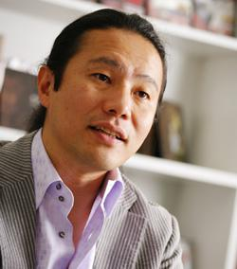](http://case.dreamgate.gr.jp/topics_detail9/id=591)**Shinichiro ISHIKAWA**

**(Founder and President, GONZO K.K.)**

●Professional Career  
Shinichiro Ishikawa graduated from University of Tokyo, MSc in Physics (Astrophysics

and Cosmology), the School of Science, and holds an MBA from INSEAD (the European Institute of Business Administration) with honors: Dean's List and The Lister Vickery Memorial Award in Entrepreneurship

Ishikawa joined The Boston Consulting Group (BCG) in 1991 and was involved in many projects related to new business development, corporate strategy/vision and alliances in the high-tech telecommunications and media convergence arena.

In 1996 he founded Digimation while working at BCG. His partner ran the company until he resigned from BCG in 1999 and joined Digimation as President. After merging with GONZO in 2000 to create GONZO DIGIMATION HOLDING K.K. (GDH), he became President and CEO. In 2008, GDH changed its name to GONZO K.K. and he currently serves as Representative Director and Founder of GONZO.

説明: bb29a1ea15ce36d3e80963fd3af33a87e850b10f.png

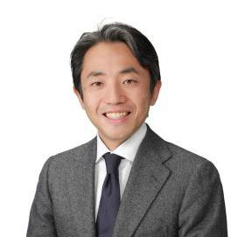

**Kotaro YAMAGISHI**

**(CEO, Keio Innovation Initiative, Inc.)**

●Professional Career   
Kotaro Yamagishi serves as CEO of Keio Innovation Initiative, Inc.

He co-founded GREE in December 2004, and now serves as the Company's director (part-time). Earlier in his career, he was editor-in-chief of CNET Networks Japan (now ASAHI INTERACTIVE, Inc.) prior to which, he worked at Nikkei Business Publications, Inc. He graduated from Keio University, Economics.

**参访企业介绍 (\*2017)参考**

**Company Visit**　　　　　　　　　　　　　　　　　　　　　　　　　　　　　　　　　　　　　　　　　　ASKUL Corporation

http://www.askul.co.jp/kaisya/english/

**日程表**

**2018** **Program Schedule**

|  |  |  |  |  |  |
| --- | --- | --- | --- | --- | --- |
| 庆应义塾大学创业者育成项目  **Keio Entrepreneurship Program** | | | | | |
| 月日  date | 09:50-10:00 | 10:00-12:00 | Lunch | 13:15-15:15 | 15:30-17:00 |
| 2月4日  (周日）  Feb.4  (Sunday) |  | 从国内出发  乘坐国际航班抵达日本东京  当晚举办欢迎会  Go from home  Take international airline to Tokyo Japan  Hold welcome party the night when arrive | | |  |
| 2月5日  （周一）  Feb.5  (Monday) |  | 参观浅草寺，秋叶原，台场  Visit Sensoji,AKIBA,odaiba | | |  |
| 2月6日  （周二）  Feb.6  (Tuesday) | Welcome Remarks | Lecture 1 |  | Lecture 2 | Orientation  Group Work  （发表准备） |
| 2月7日  （周三）  Feb.7  (Wednesday) |  | Lecture 3 |  | Lecture 4 | Group Work  （发表准备） |
| 2月8日  （周四）  Feb.8  (Thursday) |  | Lecture 5 |  | Company Visit |  |
| 2月9日  （周五）  Feb.9  (Friday) |  | Lecture 6 |  | Lecture 7 | Group Work  （发表准备） |
| 2月10日  （周六）  Feb.10  (Saturday) |  | 日本文化体验（茶道、浴衣）  Experience Japan culture(Tea ceremony、Kimono) | | |  |
| 2月11日  （周日）  Feb.11  (Sunday) |  | 自主研修  Research and study by yourself | | |  |
| 2月12日  （周一）  Feb.12  (Monday) |  | 自主研修  Research and study by yourself | | |  |
| 2月13日  （周二）  Feb.13  (Tuesday) |  | Group Work  （发表准备） |  | **Business Idea Competition**  **&**  **Wrap- up** | **结业式** Closing Ceremony  **送别会**  Farewell party |
| 2月14日  （周三）  Feb.14  (Wednesday) |  | 搭乘航班返回国内  Go back by airline | | |  |

2017 Program Schedule（仅参考）

|  |  |  |  |  |  |  |  |
| --- | --- | --- | --- | --- | --- | --- | --- |
| **Keio Entrepreneurship Program** | | | | | | | |
| 月日 | 09:50-  10:00 | 10:00-12:00 | Lunch | | | 13:15-15:15 | 15:30-17:00 |
| 2月9日（四） |  | Arrival  全员 从国内出发  乘坐国际航班抵达日本东京机场  当晚举办欢迎会 | | | | |  |
| 2月10日（五） |  | One-Day Tour in Tokyo  东京一日游（浅草寺，秋叶原，御台场） | | | | |  |
| 2月11日（六） |  | Cultural Experience  文化体验（茶道、浴衣） | | | | |  |
| 2月12日（日） |  | Free  自由活动 | | | | |  |
| 2月13日（一） | **Welcome Remarks** | **What is Entrepreneurship？**  Kanetaka MAKI  (Assistant Professor, National  Graduate Institute for Policy Studies) | |  | **Value Proposition/ What is Your Value Proposition?**  Naonori KIMURA (Partner,Managing Director, Industrial Growth Platform, Inc.) | | Preparation for the Final Presentation  （发表准备） |
| 2月14日（二） |  | **Writing Your Business Plan: Business Model and Business Strategy**  Masahiro OKADA (Professor, Keio Business School) | |  | **Innovative Management**  **- Honda Way; Some Suggestions for Entrepreneurs**  Toshikata AMINO (Executive Vice President (Retired), Honda of America Mfg., Inc.) | | 15:25 Orientation  Preparation for the Final Presentation  （发表准备） |
| 2月15日（三） |  | **Ups & Downs of Tully's Coffee Japan Co.,Ltd. ..and Beyond..**  Hitoshi SUGA (Special Advisor to President (ex- Vice Chairman), Tully's Coffee Japan Co.,Ltd.) | |  | **Company Visit**  **＜企业访问＞**  **ASKUL Corporation** | |  |
| 2月16日（四） |  | **Fund Raising, What are Investors Looking For?**  Nobuaki KITAGAWA (Managing Director, CEO of CyberAgent Ventures Beijing Co.,Ltd.) | |  | **Can Anime Conquer the World?**  Shinichiro ISHIKAWA (Founder and President, GONZO K.K.) | | Preparation for the Final Presentation  （发表准备） |
| 2月17日（五） |  | Preparation for the Final Presentation（发表准备） | |  | **Business Idea Competition & Wrap-up**  Kotaro YAMAGISHI (CEO, Keio Innovation Initiative, Inc.) | | **Closing Ceremony**  **结业式**  **Farewell Party**  **送别会** |
| 2月18日（六） |  | Departure  搭乘航班返回国内 | | | | |  |

**项目费用 ：**208000日元（约12600元人民币）

Program Fee:208000yen(About RMB12600)

\*以上日元对人民币汇率仅供参考,请以当日银行官方价格为准

The Japanese yen exchange rate is only for reference, please refer to the official price of the same day.

**费用包括：**报名费，学费，海外医疗保险费，邀请函国际邮递费，欢迎欢送会餐费，住宿费，课程期间交通费

Include:Registration fee,Tuition fee,Overseas medical insurance premium,Invitation international mailing cost,Welcome and farewell party dinner fee,Accommodation fee,Traffic expense during the program.

**不包括的费用：**国际机票费，个人护照办理费，签证手续费，国内交通费，餐费，行李超重费，自由活动时产生的费用，个人购物消费，其它“费用包括”以外的费用。

Exclude:international airfare,passport application fee,visa fee,domestic transportation fee,meals,[excess luggage charge](http://www.baidu.com/link?url=2DoW4RQlSPFsWD5GtJr-rkXLhGhMDp4jgz8iyxdTYpVCP2NUWX7eeJiLOjk_I8L-SFuGLwvnsaSaYbX0yODP7rOq2THYfPIyLYGsLRxBTznvUc9JMUYLVIvWa22J4Ppx" \t "https://www.baidu.com/_blank),cost when you have free time for activities and go shopping by yourself.

**不包含费用说明：**国际往返机票费：约4000元人民币（含税）参加学生统一购买

Excluding fees remark:International round-trip fare is about RMB4000(including tax)will be bought together for the students who take art in the program.

**餐食费用：**调研期间不统一组织就餐，同学自行大学周围就餐。

Dining cost: Meals will not be provided during the study period. Students can choose to dine around the university.

**接送机指定机场：东京成田或羽田机场。接机指定时间：2月4日（11：00—16：00）指定时间外到达的同学需自行前往住宿地点。**

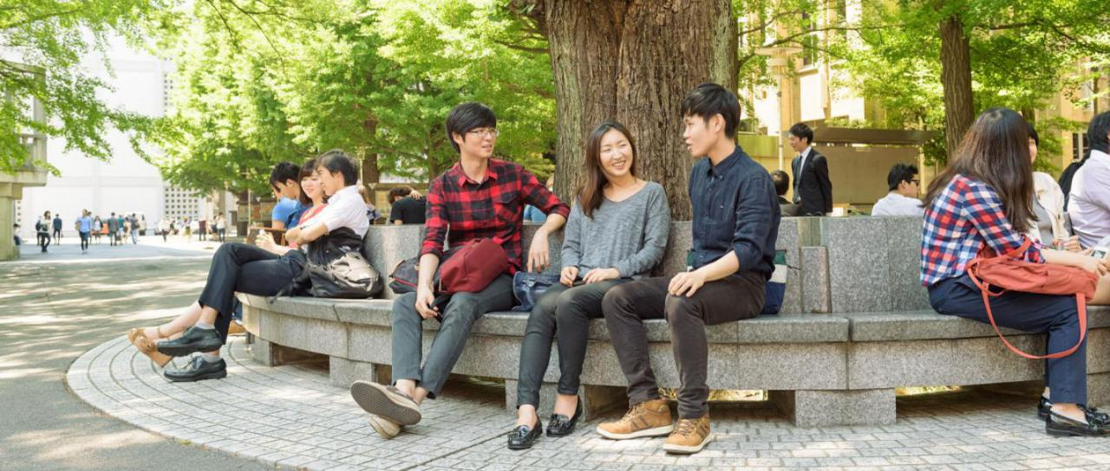

**报名方式:**

**Application method**

1. 报名方式：登陆网址：<http://suo.im/lHAce> 在线填写报名信息（请于电脑客户端登陆后填写）
2. 同时提交报名表，发送至 [shdq@xf-world.org](mailto:shdq@xf-world.org)
3. 咨询电话：021-55661085，邮箱：[shdq@xf-world.org](mailto:shdq@xf-world.org)